DESCRIPTION

Restoration Shop AL- Acrylic Lacquer
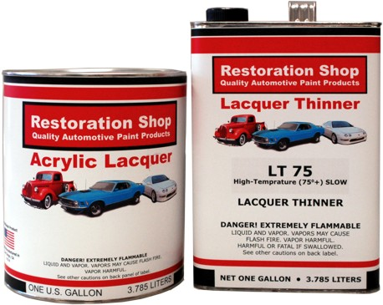
Restoration Shop AL Series Acrylic Lacquer is a fast dry, acrylic based lacquer system designed for Automotive Restoration Purposes. AL Series Acrylic Lacquer single stage colors can be polished to a full gloss. CL3245 High Performance Acrylic Lacquer Clear coat may be used to give more depth of color and added durability as well as making polishing easier.

COMPONENTS

- AL - Acrylic Lacquer Color
- LT 70 - Lacquer Thinner
- LT 85 - High Gloss Lacquer Thinner
- CL3245 - High Performance Acrylic Lacquer Clear

MIXING RATIO
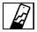
Reduce 100% with LT Lacquer Thinner. Use one part lacquer to one part thinner (1:1). AL Kit contains the exact amount required to obtain the 1 : 1 Mix Ratio.

CLEAN UP

KT912 (Check local regulations)

ADDITIVES

- KR100 Retarder
- KE215 Fisheye Eliminator

SURFACE PREPARATION
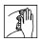
USE RECOMMENDED UNDERCOAT SYSTEM FOLLOWING RECOMMENDED PROCEDURES.
- Wipe with KW901 Grease and Wax Remover or KW902 Anti-Static Panel Kleaner
- Abrade with 150 grit then 320 grit sandpaper or equivalent.

- Wipe again with KW901 Grease and Wax Remover or KW902 Anti-Static Panel Kleaner
- For best results apply anti-corrosive primer such as KEP Series epoxy primers over bare metal.

SUBSTRATES

AL Series Acrylic Lacquer may be applied over: Cleaned, sanded and primed OEM or Refinish topcoat. Kustom Shop KEP Epoxy Primer / Sealer. KPP Polyester Primer, Kustom Shop KL611 Old school Acrylic Lacquer Primer.

DRY TIMES

AIR DRY @ 77°F
Tack Free 5-10 minutes
To Tape 1 Hour
To Recoat Overnight

Optional Clear coating: If desired, a clear coat can be applied to provide additional long term durability and wet-look appearance. CL3245 High Performance Acrylic Lacquer Sunscreening Clear. Mix 1 : 1 with LT85 High Gloss Lacquer Thinner. Apply 3-4 coats before clearcoat. Allow the final coat of color to dry a minimum of 30 minutes but no longer than 24 hours before applying clear. After 24 hour, color must be sanded and additional coat of color applied. To avoid the risk of crazing, it is best to apply all coats of lacquer on the same day.

APPLICATION

For Air Spray
- Spray 3-4 medium wet coats or to full hiding is achieved
- Allow 5 -10 minutes @ 70° F flash time between coats

GUN SETUPS

CONVENTIONAL
Gravity Feed 1.5 mm - 1.8 mm
Siphon Feed 1.5 mm - 1.8 mm

HVLP 043 - .052

AIR PRESSURES

CONVENTIONAL @ GUN
Gravity Feed 35 - 40 psi
Siphon Feed 40 - 50 psi

HVLP @ Cap 8 - 10 psi

PHYSICAL DATA
VOC AL Color or Clear 5.2 lbs/gal (624 g/l) max
VOC LT 70 Medium 5.89 lbs/gal (706 g/l)
VOC LT 85 Slow 4.85 lbs/gal (582 g/l)
VOC mixed 1:1 with LT 70 Medium 5.54 lbs/gal (664 g/l)
VOC mixed 1:1 with LT 85 Slow 5.02 lbs/gal (602 g/l)
Flash Point 53ºF

POLISHING
Air Dry 24 hours minimum before polishing.

SAFETY

Before using any Restoration Shop product, be sure to read all MSDS and application instructions and warnings. Always wear a properly fitted air purifying respirator with organic vapor cartridges and particulate filter or a fresh air respirator (depending on product selection), eye protection, gloves and protective clothing during application and until vapors are exhausted. Do not permit anyone without protection in the painting area. This product is intended for use by a professionally trained painter. Keep out of the reach of children.

IMPORTANT: The data on this sheet represent typical values obtained by the methods indicated. Since application variables are a major factor in product performance, this information should serve only as a general guide. Restoration Shop assumes no obligation or liability for use of this information. Unless Restoration Shop agrees otherwise in writing, RESTORATION SHOP MAKES NO WARRANTIES, EXPRESS OR IMPLIED, AND DISCLAIMS ALL IMPLIED WARRANTIES INCLUDING WARRANTIES OF MERCHANTABILITY OR FITNESS FOR A PARTICULAR USE OR FREEDOM FROM PATENT INFRIGNEMENT. RESTORATION SHOP WILL NOT BE LIABLE FOR ANY SPECIAL, INCIDENTAL OR CONSEQUENTIAL DAMAGES.
Unless Restoration Shop agrees otherwise in writing, Restoration Shop’s only obligation for any defect in this product under any warranty that Restoration Shop provides or under any other legal theory will be to replace the defective product, or to refund its purchase price, at Restoration Shop’s option.

