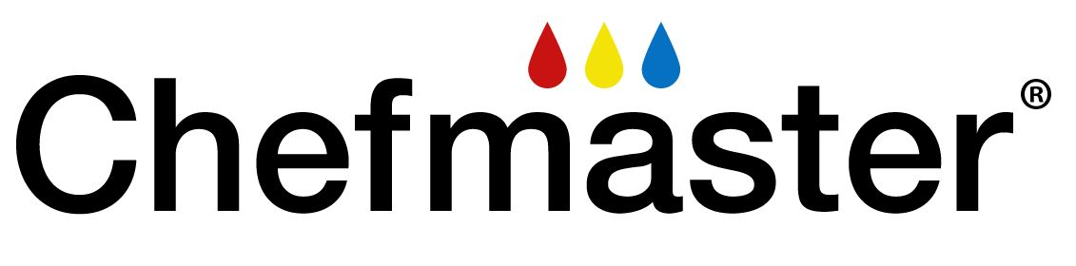

NUTRITIONAL PROFILE

PRODUCT: AIRBRUSH CLEANER

(PER 100 GRAMS OF INGREDIENTS) - CALCULATED

CALORIES: 0.00 FAT: 0.00 g
MOISTURE: UNK g SATURATED: 0.00 g
PROTEIN: 0.00 g UNSATURATED: 0.00 g
ASH: 0.00 g MONOUNSATURATED: 0.00 g
CARBOHYDRATES: 0.00 g POLYUNSATURATED: 0 .00 g
SUGARS: 0.00 g TRANS FATTY ACIDS: 0.00 g
ADDED SUGAR: 0.00 g CHOLESTROL: 0.00 mg
VITAMIN D: 0.00 mg TOTAL DIETARY FIBER: 0.00 g
THIAMIN: 0.00 mg SOLUBLE: 0.00 g
NIACIN: 0.00 mg NE INSOLUBLE: 0.00 mg
RIBOFLAVIN: 0.00 mg IRON: 0.00 mg
SODIUM: 0.00 mg CALCIUM: 0.00 mg
POTASSIUM: 0.00 mg

G=gram, mg=milligram, IU=INTERNATIONAL UNITS AND NE= NIACIN EQUIVALENT.

